*Florida International University*

*School of Computing and Information Sciences*

CIS 4911 - Senior Capstone Project

Software Engineering Focus

Feature Document

User Story # 707

**Team Member:**

Garrett Lemieux

**Product Owner(s)**:

Francisco Ortega

**Mentor(s)**:

Francisco Ortega

**Instructor**: Masoud Sadjadi

**User Story – Integrate Real Sense into Default Mode**

* As a User I would like to have default modes set when using Real Sense device in order to allow for expected functionality with Interactive Paint.
* **Acceptance Criteria**:
  1. Application should have preset modes for different combinations of devices which includes when Real Sense device is connected to application.
  2. Modes should be automatically set when application starts.

**Use Case: User needs default mode when real sense is used**

User wants to have default modes set and running when Real Sense device is connected to application and the application starts.

* Details:
* Actor:
  + User
* Pre-conditions:
  + TouchPoints app is running.
  + Real Sense connected.
* Description:
  + Use case begins when User has Real Sense device plugged in and starts application.
  + User is informed of connected devices and default mode set.
  + Use case ends when user ends application.
* Post-conditions:
  + Appropriate default mode should be set when each combination of devices is connected with Real Sense device.
* Decision Support:
  + Frequency: Medium, Real Sense device will not always be used in application.
  + Criticality: High, User must have predefined mode when Real Sense device is connected.
  + Risk: Low
* Usability:
  + Need to know the predefined modes and what the functionality of each mode allows.
  + Needs to know what devices are connected to program when application starts.
* Reliability
  + High
* Performance
  + Performance High
  + Failure Low
* Supportability
  + Real Sense Device
  + Multi-Touch Screen (ACER)
  + Leap Motion Device
  + EyeX
* Modification History:
  + Owner: Garrett Lemieux
  + Initiation Date 4/6/2016
  + Date last Modified: 4/16/2016

**Use Case Diagram**

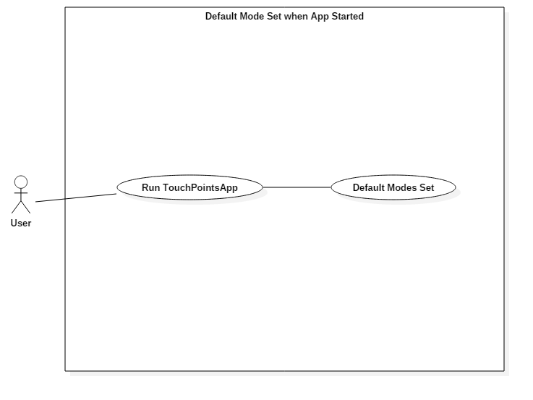

**Sequence Diagram**

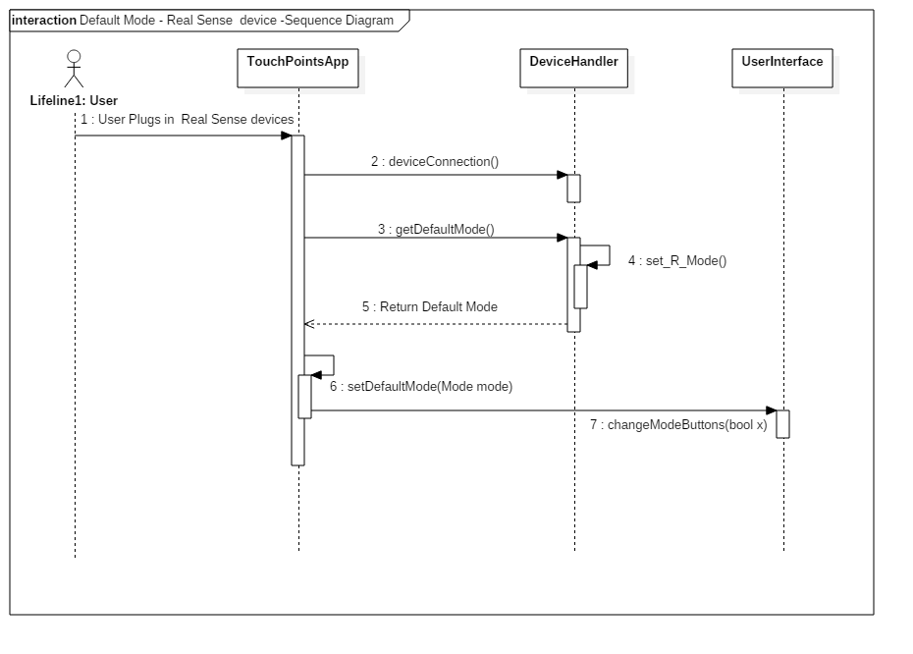

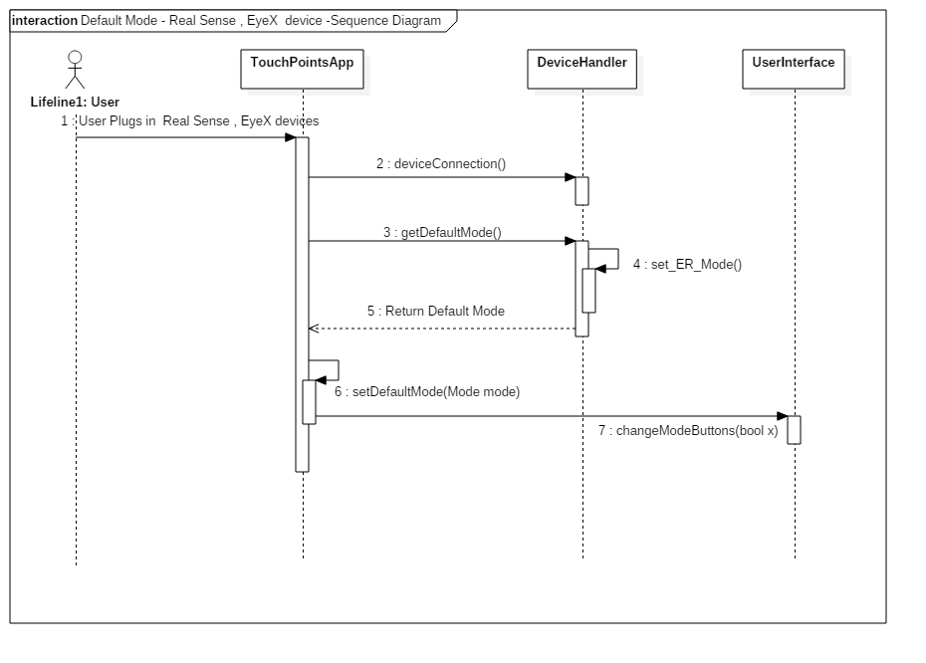

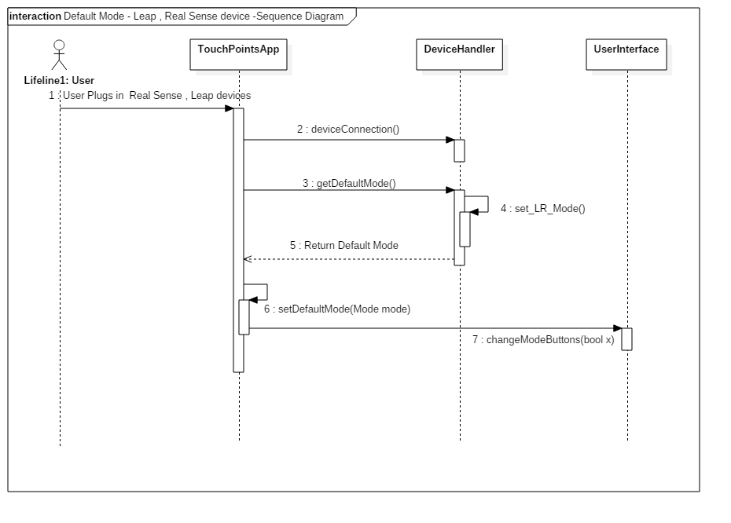

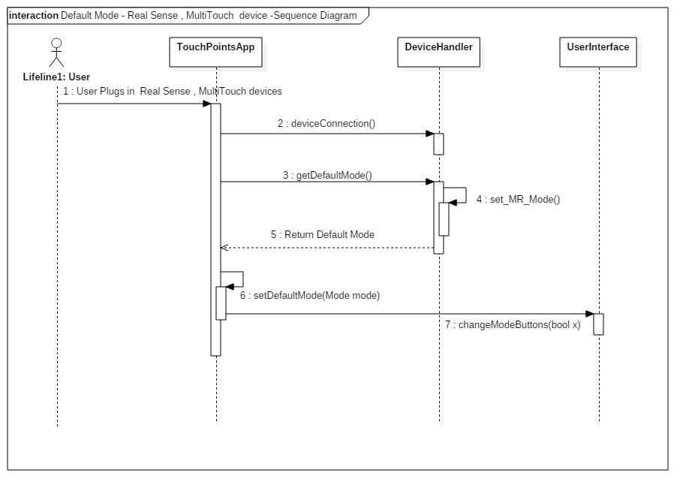

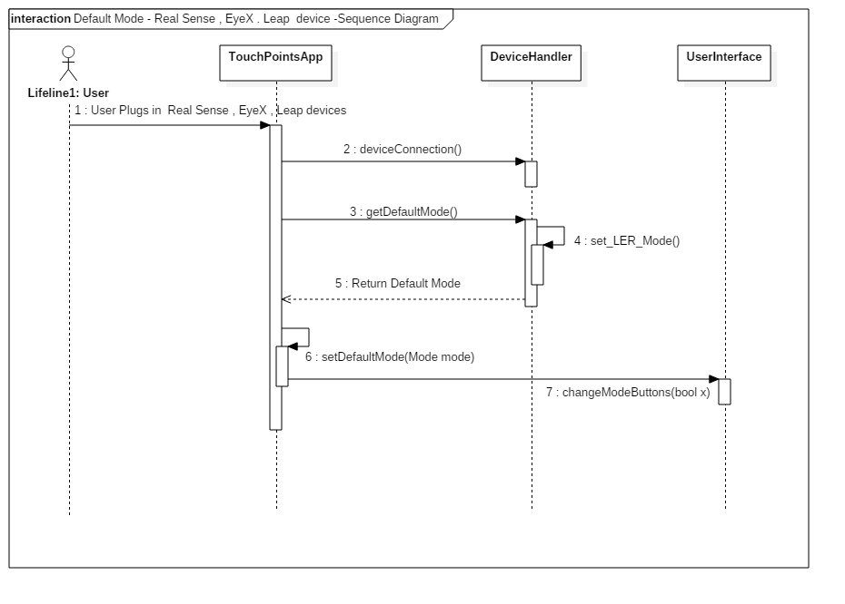

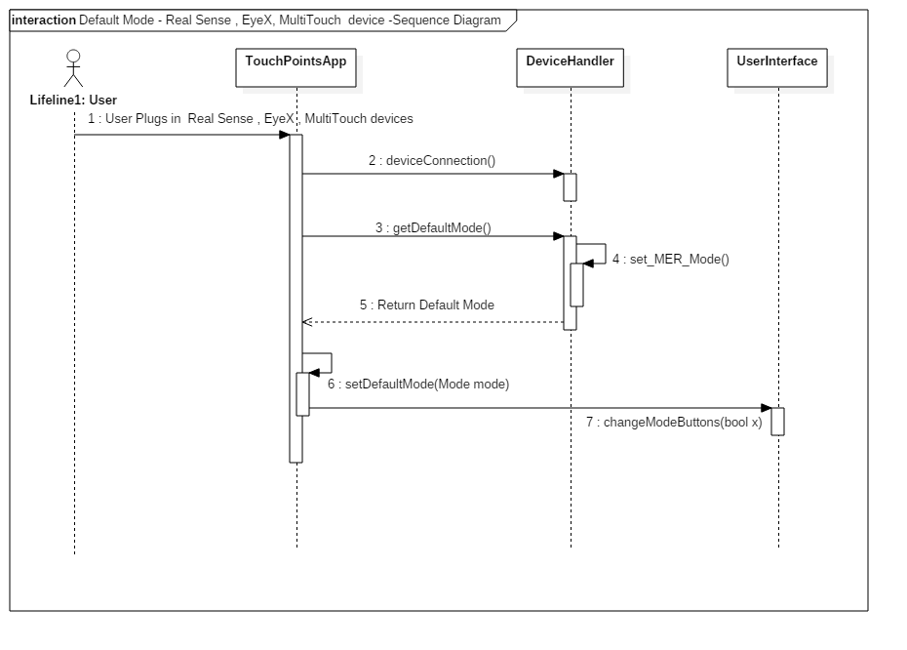

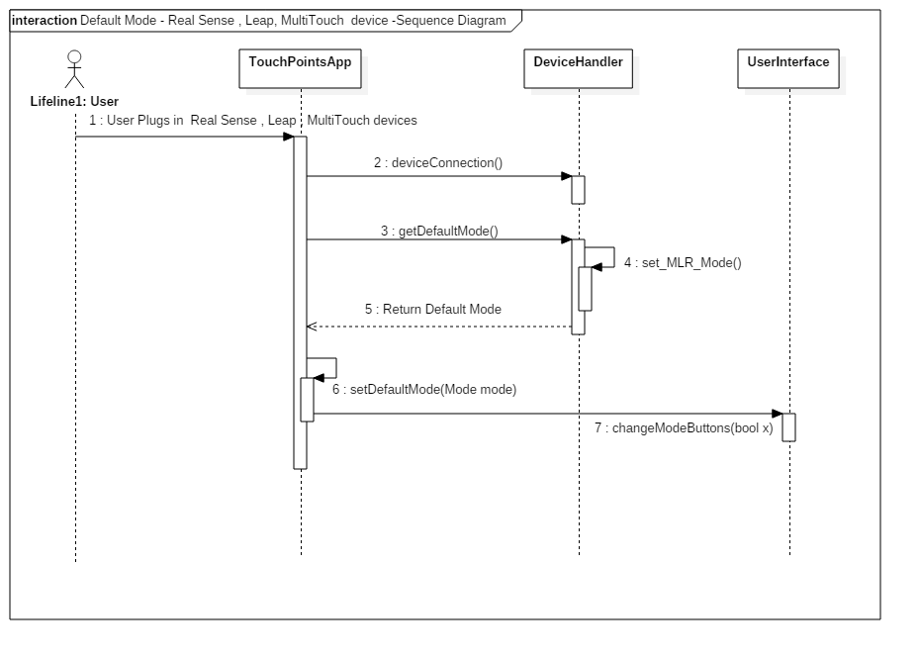

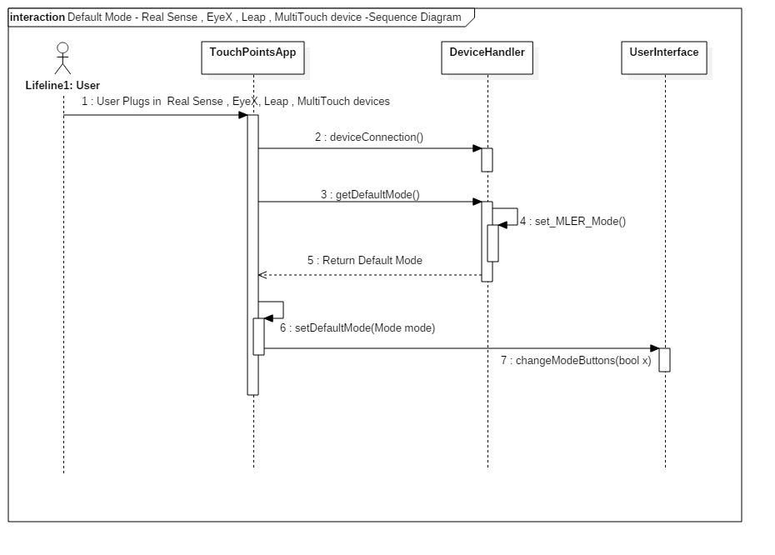

Cl**ass Diagram**

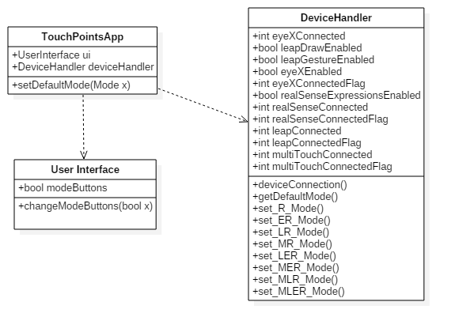

**Unit Test**

* Sunny Day Test:
  + Test Case  - Real Sense ,MultiTouch, and Leap Motion, EyeX Connected
    - Test Purpose: To determine if the correct mode is set when these four devices are connected at the start of the application.
    - Test Procedure: User plugs in the multitouch screen the leap motion, Real Sense, and eyeX and starts the application. User performs Real Sense facial gestures. User draws with multitouch screen and presses all buttons. User pulls up UI displays with eyes.
    - Expected Results: Real Sense facial gestures should be read by Real Sense device. User should be able to draw with multitouch screen and buttons displayed in upper left hand corner and UI menu using eyeX. Radial menu should be functioning.
  + Test Case  - Real Sense ,MultiTouch, and Leap Motion Connected
    - Test Purpose: To determine if the correct mode is set when these three devices are connected at the start of the application.
    - Test Procedure: User plugs in the multitouch screen the leap motion and Real Sense device and starts the application. User performs Real Sense facial gestures. User draws with multitouch screen and presses all buttons.
    - Expected Results: Real Sense facial gestures should be read by Real Sense device. User should be able to draw with multitouch screen and buttons displayed in upper left hand corner. Radial menu should be functioning.
  + Test Case  - Real Sense ,MultiTouch, and EyeX Connected
    - Test Purpose: To determine if the correct mode is set when these three devices are connected at the start of the application.
    - Test Procedure: User plugs in the multitouch screen the eyeX and Real Sense device and starts the application. User performs Real Sense facial gestures. User draws with multitouch screen and presses all buttons. User pulls up UI screens using eyes.
    - Expected Results: Real Sense facial gestures should be read by Real Sense device. User should be able to draw with multitouch screen and buttons displayed in upper left hand corner if eyes look in upper left hand of canvas. Radial menu should be functioning.
  + Test Case  - Real Sense, Leap Motion, and EyeX Connected
    - Test Purpose: To determine if the correct mode is set when these three devices are connected at the start of the application.
    - Test Procedure: User plugs in the Real Sense device, the leap motion and eyeX and starts the application. User performs Real Sense facial gestures. User draws with Leap motion.
    - Expected Results: Real Sense gestures should be read by Real Sense device. User should be able to draw with Leap Motion and buttons displayed in upper left hand corner. Proximity menu and Radial menus should not be functioning. UI menu only show if user uses eyeX and looks in specified location.
  + Test Case  - Real Sense and Leap Motion connected
    - Test Purpose: To determine if the correct mode is set when leap motion and Real Sense device are connected at the start of the application.
    - Test Procedure: User plugs in the Real Sense device and the leap motion and starts the application. User performs Real Sense facial gestures.  User draws with Leap motion.
    - Expected Results Real Sense gestures should be read by Real Sense. User should be able to draw with Leap motion. Buttons in upper left hand corner should not be displayed. Both radial menu and proximity menus should not be active.
  + Test Case  - Real Sense and MultiTouch connected
    - Test Purpose: To determine if the correct mode is set when Real Sense device and multitouch devices are connected at the start of the application.
    - Test Procedure: User plugs in the multitouch screen and Real Sense starts the application. User draws with multitouch screen and uses radial button. User performs Real Sense facial gestures.
    - Expected Results: User should be able to draw with multitouch screen and buttons displayed in upper left hand corner. Radial menu should be functioning. Real Sense device should be able to read facial gestures.
  + Test Case  - Real Sense and EyeX connected
    - Test Purpose: To determine if the correct mode is set when eyeX and Real Sense device are connected at the start of the application.
    - Test Procedure: User plugs in the Real Sense device and EyeX starts the application. User turns on UI menu with eyes. User draws with Real Sense device and performs Real Sense facial gestures.
    - Expected Results: User should be able to draw with Real Sense device and Real Sense facial gestures should be read. Buttons in upper left hand corner should not be active. EyeX should be able to turn on UI with eye gaze in specified region.
  + Test Case  - Real Sense connected
    - Test Purpose: To determine if the correct mode is set when only Real Sense is connected at the start of the application.
    - Test Procedure: User plugs in Real Sense device and starts the application. User tries to draw with Real Sense and perform real Sense Facial Gestures.
    - Expected Results: User should be able to draw with Real Sense and facial gestures should be read. The UI menu should be present and showing at all times and buttons in left hand corner should not be visible or active.
* Rainy Day Test:
  + Test Case  - Real Sense, MultiTouch, Leap Motion, and EyeX Connected User tries to Draw with leap Motion
    - Test Purpose: To determine if the user can make leap gestures when real sense device is connected.
    - Test Procedure: User plugs in the multitouch screen the leap motion and eyeX, Real Sense and starts the application. User then tries to draw with the leap motion.
    - Expected Results: User should not be able to draw with leap motion since the default mode specifies this when all four devices are connected.
  + Test Case  - Real Sense, MultiTouch and Leap Motion Connected User tries perform leap motion gestures.
    - Test Purpose: To determine if the user can perform leap motion gestures when default mode is set for specified devices
    - Test Procedure: User plugs in the multitouch screen the leap motion and Real Sense and starts the application. User then tries to perform leap motion gestures.
    - Expected Results: Leap motion should not be able to read leap gestures since the default mode specifies this when real sense and leap are connected.

**Integration Testing**

* The default modes were successfully set when all combinations of devices were connected including Real Sense.
* Each combination of devices was first connected to local machine and then application started. Each time the functionality of the program was checked for specific default mode.
* After integrating default modes into the application all previous functionality was maintained and functioning correctly.

**User Guide**

* The user does not have to do anything special. The default modes will be set depending on the devices connected.
* The user may choose any device he or she wants to work with and by plugging in the devices the application will detect the devices connected and set the default mode.
* The pictures below show some examples of what the user should expect to see with the different device plugged in.
* Multitouch , Leap Motion , Real Sense

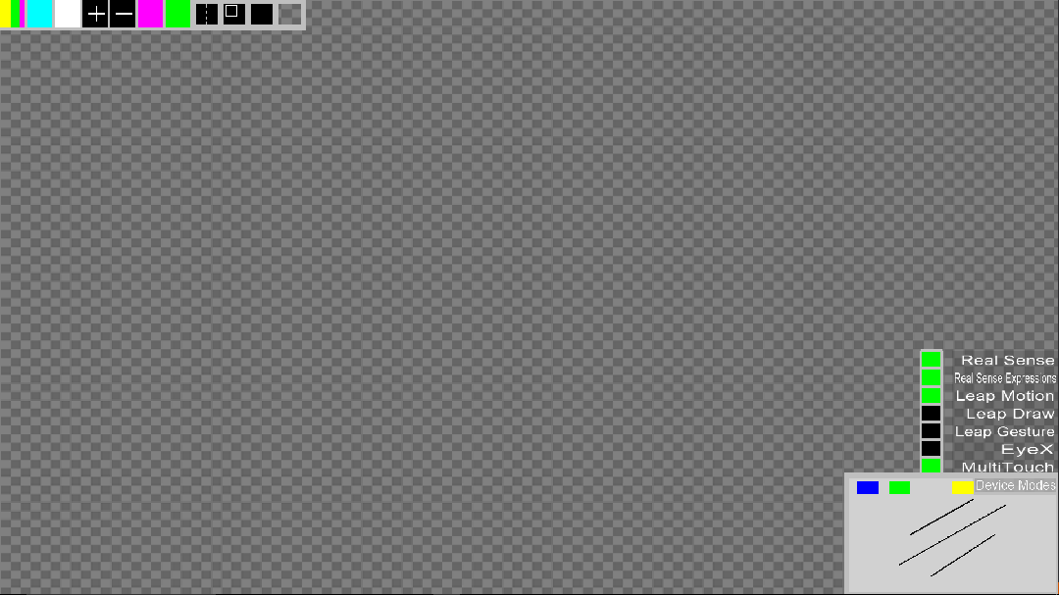

**Glossary**

* **Default Mode -** predetermined settings that are dependent on the devices connected to the application at start time.